Universidad Politécnica de Valencia

Escuela Técnica Superior de Ingeniería Informática

Statistical Study of the

StackOverflow’s Survey 2022

for the Iberian Peninsula.

Author: Rodríguez Díaz, Gabriel  
Tutor: Zarzo Castelló, Manuel

**Introduction**

**Previous Concepts:**

* **StackOverflow:** This website is one of the most iconic forums for programming related questions and problem solving.

Every year, a survey is carried out in order to study the status of the IT environment.

* **Blockchain:** Is a technology that allows the possibility of creating shared, immutable ledgers that ensures the veracity and reliability of the transactions.

Its usage is controversial among the developers’ community because it is the core technology for other polemic concepts such as cryptocurrencies or NFTs.

* **Operative System:** The operative system is the core of a computer. It is the tool that allows people to work easily with computer.

That is why most of the developers have a preference between the Big Three, Linux, Apple and Windows.

**About the dataset:**

For this assignment the dataset chosen was the one providen by the

[2022 Developer Survey](https://survey.stackoverflow.co/2022/). You can get the file from [Kaggle](https://www.kaggle.com/datasets/dheemanthbhat/stack-overflow-annual-developer-survey-2022).

In the original dataset, there are several aspects collected. Some are work related and others are more personal. Nevertheless, in this project we are focusing our attention on an array of variables that may be interesting to analyze and compare.

Summarizing, in the original dataset, there are 78 variables, of which we are using 4 continuous and 4 cualitatives.

The following table shows the variables, its type and a brief description.

|  |  |
| --- | --- |
| **Cuantitative Variables** | |
| **Variable** | **Description** |
| Years of Code  (**X1**) | The years that a person has been coding. It can be useful to know how much years of studying code it takes for someone before they start coding. |
| Years of Code Pro (**X2**) | The years that a person has been coding with some kind of remuneration. |
| Yearly Salary (**X3**) | The amount in **euros** that the surveyed people perceive a **year**. |
| Age (**X4**) | The range of age of each surveyed person. |

TABLE 1. Numerical variables table.

|  |  |
| --- | --- |
| **Cualitative Variables** | |
| **Variable** | **Description** |
| Country (**F1**) | One of the two countries picked for the assignment: **Spain** or **Portugal** |
| Education (**F2**) | The alevel of studies that the person has. |
| OS used for work (**F3**) | Which operative system does the person use to carry out its work. |
| Blockchain opinion (**F4**) | The opinion of each surveyed person about the blockchain technology. |

TABLE 2. Cualitative variables table.

Once we have the cualitative variables, it is time to qualify some things about the variables.

* **Age:** The range of eligible ages is the following. For the sake of simplicity, the option “prefer not to say” has been excluded since there was only one record matching that option.

|  |
| --- |
| **Ranges (Years)** |
| [18,24] |
| [25,34] |
| [35,44] |
| [45,54] |
| [55,64] |

TABLE 3. Ranges of variable Age

* **Years of Code Pro:** In the dataset, there was a variable called “Years Of Experience”. Nevertheless, the survey takes only people who are developers or write code as part of their work, then, we may considere this variable as a representative of the professional experience.
* **Education:** This variables referes to the level of study of each person. The following table indicates the possible options.

|  |  |
| --- | --- |
| **Education Level (Title)** | **Equivalent in Spanish** |
| Primary/Secondary/None/Something Else | Primaria/Secundaria/Ninguno /Otros |
| Professional degree (JD, MD, etc.) | FP Grado Medio |
| Associate degree (A.A., A.S., etc.) | FP Grado Superior |
| Some college/university study without earning a degree | Estudios de grado sin terminar. |
| Bachelor’s degree (B.A., B.S., B.Eng., etc.) | Grado Universitario |
| Master’s degree (M.A., M.S., M.Eng., MBA, etc.) | Estudios Posgrado |
| Other doctoral degree (Ph.D., Ed.D., etc.) | Doctorado |

TABLE 4. Education Levels and its equivalent in the Spanish System. Where Bachelor´s Degree, Master´s Degree and Doctoral degree are considered high level degrees.

In the dataset there are individual options for Primary, Secondary, None and Something else, but we are grouping them since they are not so relevant and do not teach code.

* **OS used for work:** The options were merged into four options:

|  |
| --- |
| **Operative System** |
| Linux Based |
| Windows |
| Apple |
| Combination |

TABLE 5. OS groups for the variable Operative System used for work.

Without entering in much detail, we are considering the subsystem terminals for Windows, Windows Server as Windows, other Linux based systems as Android, BSD would be Linux; and IOS and MacOS are Apple.

* **Blockchain Opinion:** They are classified in a simple way:

|  |
| --- |
| **Blockchain Opinion** |
| Very Favorable |
| Favorable |
| Neutral |
| Unfavorable |
| Very Unfavorable |
| Unsure |

TABLE 6. Level of support for the blockchain technology.

**Objectives:**

* To study if there exists a relationship between the level of education and the income among the developers.
* To study the increase of the income based on the growth of the working experience.
* To Analyze if there exists a relationship between the used level of education and the opinion about blockchain.
* To review which of the countries has the most people with a Bachelor´s Degree or superior level of education.
* To get an idea of the current aging state of the laboral market in IT.
* To check if there exists a relationship between the salary and the OS used.

**Discussion about the sample and populations:**

The population, as it was said before, was all the people that filled the StackOverflow Developers´ Survey 2022 that is 73268 people.

However, for this assignment, I took a sample that implements the following filters:

* Only the people from Iberian Peninsula (Excluding Andorra, that had only 15 records). This left the sample with 2084 of 73268 records. The dataset was reduced in a 97.155%
* The ones that receive their paycheck in euros. This filtered 501 more people.
* The options “NA” and “Prefer not to say” in Age were removed, then 13 records were removed. Also the option NA in YearOfCode since everyone who answered were supposed to be programmers. These removed 1 record
* Excluded the people who did not mark their paycheck as yearly. Based on preliminary observations, this filter will reduce the outliars substantially since this option lead many people to error. After this filter 609 records were discarded.
* Finally, we are only taking into account those people who use only one Operative System at their work. Therefore, this will leave us with 495 records.

These filters were applied in the order as it is mentioned above. So, we are shrinking the size of the dataset in a 99.324%

Even with the filters applied, the sample that was taken contains plenty of useful information, nonetheless, for this assignment, only the previous mentioned variables were choosen. MATIZAR POBLACION

**Descriptive Statistics**

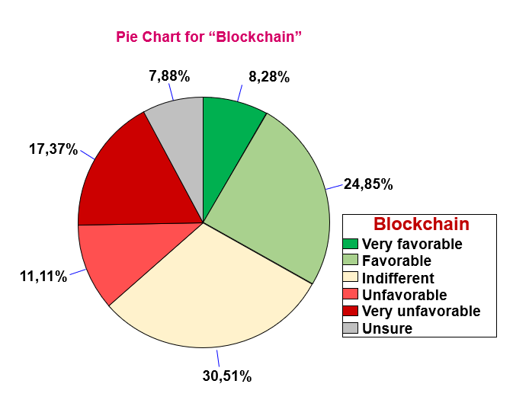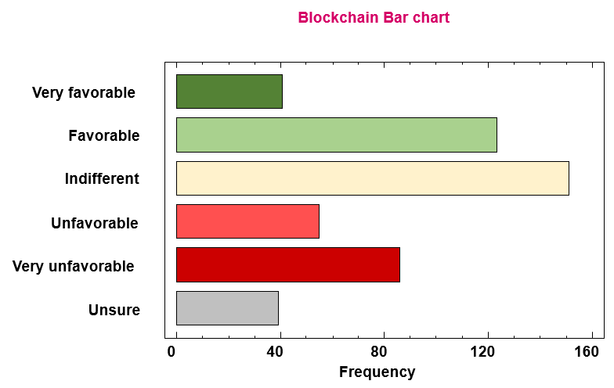**1.1 Represent the bar chart and the pie graph of the variable Blockchain:**

PICTURE 1: Bar chart for “Blockchain”

PICTURE 3: Pie chart for “Blockchain”

**1.2 Do the categories have a similar frequency?**

As we may see in both charts, there are two categories that clearly excel. Those are “favorable” and “indifferent”. After those two, we can notice that people are also very unfavorable about blockchain.

Since, it is a new technology and kinda hard to understand, there are many people indifferent or unsure about it.

Also, as we mentioned in the definition of the concept, it is very controvertial, which also explains that frequency in an opinion as extreme as very unfavourable.

**2.1 Compute the frequency table for the variable Blockchain:**

|  |  |  |  |  |  |
| --- | --- | --- | --- | --- | --- |
| **Clase** | **Valor** | **Frequency** | **Relative Frequency** | **Cumulative Frequency** | **Cum. Rel. Frequency** |
| 1 | Favorable | 123 | 0,2485 | 123 | 0,2485 |
| 2 | **Indifferent** | **151** | **0,3051** | **274** | **0,5535** |
| 3 | Unfavorable | 55 | 0,1111 | 329 | 0,6646 |
| 4 | Unsure | 39 | 0,0788 | 368 | 0,7434 |
| 5 | Very Favorable | 41 | 0,0828 | 409 | 0,8263 |
| 6 | Very Unfavorable | 86 | 0,1737 | 495 | 1,0000 |

TABLE 7. Frequency table for Blockchain

**2.2 What is computed in each of the columns?**

**Frequency:** Or absolute frequency. Shows the number of times each category of Blockchainoccurred.

**Relative Frequency:** Indicates over 1 the frequency for each value in relation with the total of occurrences for every category.

**Cumulative Frequency:** The current measured frequency taking into account the previous mentioned frequencies.

**Cumulative Relative Frequency:** The relative frequency with a cumulative criteria.

**2.3 Discuss the most relevant results:**

It is important to mention that the variable chosen was Blockchain because it is more interesting to analyze than Country.

As we can observe, Indifferent is clearly the dominant category. Its frequency comprehends almost ⅓ of the total. We could combine it with Unsure leaving us with a total of 0,3839 points

We can also discuss the other results in two subgroups which are favorable opinions (Favorable and Very Favorable) and unfavorable opinions (Unfavorable and Very Unfavorable). As it is shown, the favorable opinions have 0,3313 points while the unfavorable group have 0,2848.

Therefore, we can conclude that the vast majority of the people have not a well-formed opinion about blockchain, and, between those who has, the tendency shows that it has most supporters than detractors.

**3.1 Compute a table of crossed frequencies between Blockchain and Country.**

|  |  |  |  |  |  |  |  |
| --- | --- | --- | --- | --- | --- | --- | --- |
|  | **Very Favorable** | **Favorable** | **Indifferent** | **Unfavorable** | **Very Unfavorable** | **Unsure** | **Row**  **Total** |
| **Portugal** | **11** | 23 | 29 | 8 | 14 | 7 | 92 |
| **2,22%** | 4,65% | 5,86% | 1,62% | 2,83% | 2,22% | 18,59% |
| 11,96% | 25,00% | 31,52% | 8,70% | 15,22% | 7,61% |  |
| **Spain** | 30 | 100 | 122 | 47 | 72 | 32 | 403 |
| 6,06% | 20,20% | 24,65% | 9,49% | 14,55% | 6,06% | 81,41% |
| 7,44% | 24,81% | 30,27% | 11,66% | 17,87% | 7,94% |  |
| **Column Total** | 41 | 123 | 151 | 55 | 86 | 39 | 495 |
| 8,28% | 24,85% | 30,51% | 11,11% | 17,37% | 7,88% | 100,00% |

TABLE 8. Cross Frequency table for Blockchain and Country

**3.2 “Row Percentages” or “Column Percentages”?**

In this case, the row percentages option was choosen, since the variable Country has much less categories than Blockchain. Also, it is kinda interesting to know the percentage for each country.

**3.3 Explain the difference between Absolute and Relative Frequencies:**

**Absolute frequency:** Indicates the number of time that a value appears. The sum of all absolute frequencies is the total number of observations.

**Relative frequency:** It is the absolute frequency divided by the total number of values in the data set. It returns a value in the range of o to 1. Also, the sum of all the relative frequencies equals to 1.

**3.4 Explain the difference between Marginal and Conditional Frequencies:**

**Marginal frequency:** Those that represent the total frequencies of each value of the variable.

**Conditional frequency:** Are the ones computed based on the values of other variable.

In the case of the **TABLE 8**, the values **marked** represent the conditional frequency of Very Favorable with respect to Portugal. That is, 2,22% of the data that is from Portugal, has Very Favorable as source.

On the other hand, in “Column Total” and “Row Total” we represent the marginal frequencies of each variant with respect to the total amount of observations.

**3.5 Is there any relation between Blockchain and Country?**

As we can see in the **TABLE 8,** the percentage of the favorable opinions is higher in Portugal. While, in Spain, the percentages of the unfavourable opinions tend to be quite higher than in Portugal.

Also, the values of indifferent and unsure are more or less the same in both countries.

The relationship indicates that people based in Portugal tend to have a better view of the blockchain technology than the ones in Spain.

It could be interesting to remark that Portugal´s government [supported the cryptocurrencies in the past](https://sifted.eu/articles/crypto-families-flocking-portugal/), while the Spanish government and the Spanish CNMV [criticized the environment and even threatened](https://es.beincrypto.com/mundo-crypto-abandona-espana-acusa-gobierno-falta-apoyo/) some blockchain enterprises.

This, should be an interesting approach of why there is a correlation between both variables.

**4. Compute a table with the main statistics for each of the 4 cuantitative variables:**

|  |  |  |  |  |  |
| --- | --- | --- | --- | --- | --- |
| **Parameter** | **YearsCode** | **YearsCodePro** | **Salary** | **AvgAge** | **Type** |
| **Range** | 45 | 37 | 200000 | 38,5 | Dispersion |
| **Inter. Range** | 13 | 10 | 29000 | 10 | Dispersion |
| **Average** | 14,2389 | 9,81081 | 49722,8 | 34,3566 | Position |
| **Median** | 12 | 8 | 44500 | 29,5 | Position |
| **Variance %** | 61,8641 | 74,5074 | 58,0181 | 24,6291 | Dispersion |
| **Standard Deviation** | 8,80874 | 7,30978 | 28848 | 8,46173 | Dispersion |
| **S. Skewness Coefficient** | 9,04454 | 9,92841 | 16,6149 | 4,923 | Shape |
| **S. Kurtosis Coefficient** | 3,04172 | 4,1722 | 23,8612 | 0,69144 | Shape |

TABLE 9. Analysis of the cuantitative variables

Note that for this analysis I have used a different variable, that is the average of the ages. I substituted the ranges by the average between the minimum and the maximum. For example, for the range [25 ; 34] its value would be 29,5

**5. Create a normal probabilistic plot and using it along the Standard Skewness Coefficient and the Standard Kurtosis Coefficient indicate which variable can be taken as X1:**

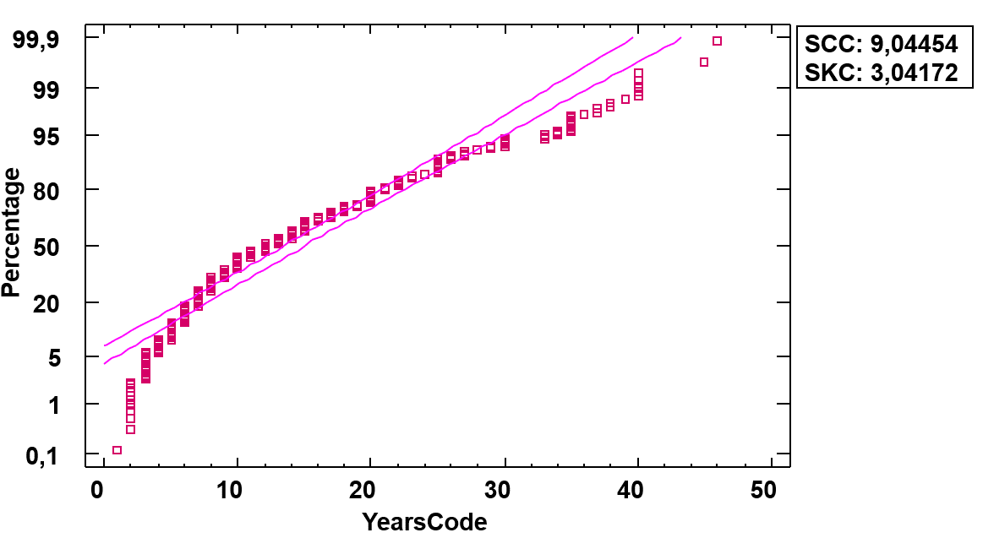

PICTURE 4: Normal Probabilistic Plot for YearsCode

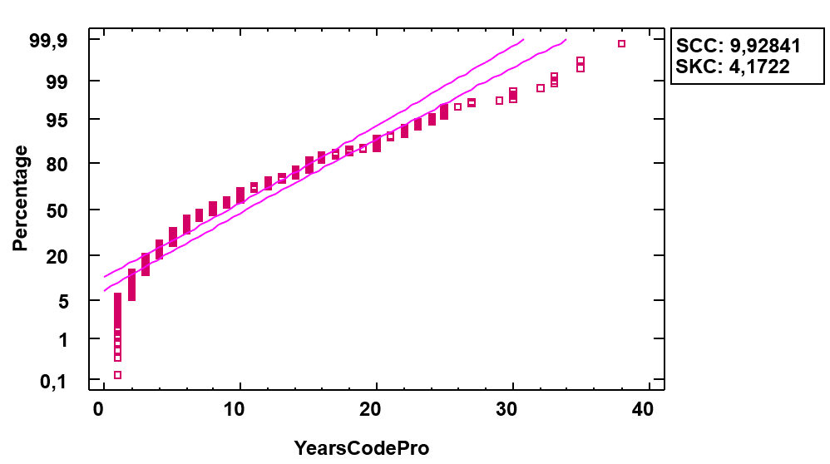

PICTURE 5: Normal Probabilistic Plot for YearsCodePro

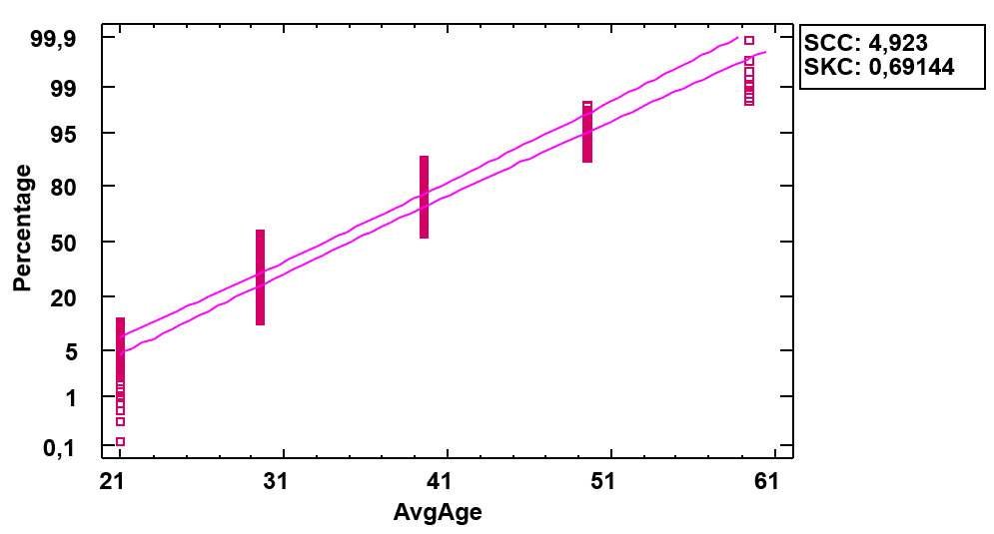

PICTURE 6: Normal Probabilistic Plot for AvgAge

PICTURE 7: Normal Probabilistic Plot for Salary

Firstable, we should briefly define the Standard Skewness Cofficient and the Standard Kurtosis Coefficient, since those are the parameters we are considering to choose our variable.

* **Standard Skewness Coefficient:** Is a measure for the skewness of the distribution. Being 0 a perfect symmetry.
* **Standard Kurtosis Coefficient:** Is a measure that indicates the level of peakedness of a distribution.

To choose variable based on this criteria, we should look for a variable that has the most closed to zero coefficients. Both Skewness and Kurtosis.

This indicates that the distribution is quite symmetrical and less peaked, which makes it easier to perform statistical computations and interpretate the results.

**6. Place a histogram for each of the variables. If needed, you may change the intervals arguing why:**

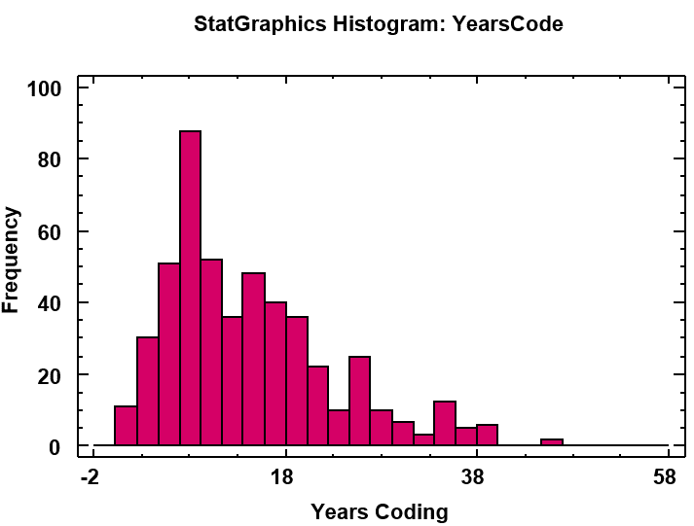

PICTURE 8: Statgraphics Histogram for YearsCode

PICTURE 9: Histogram for YearsCode 16 clases lim 46

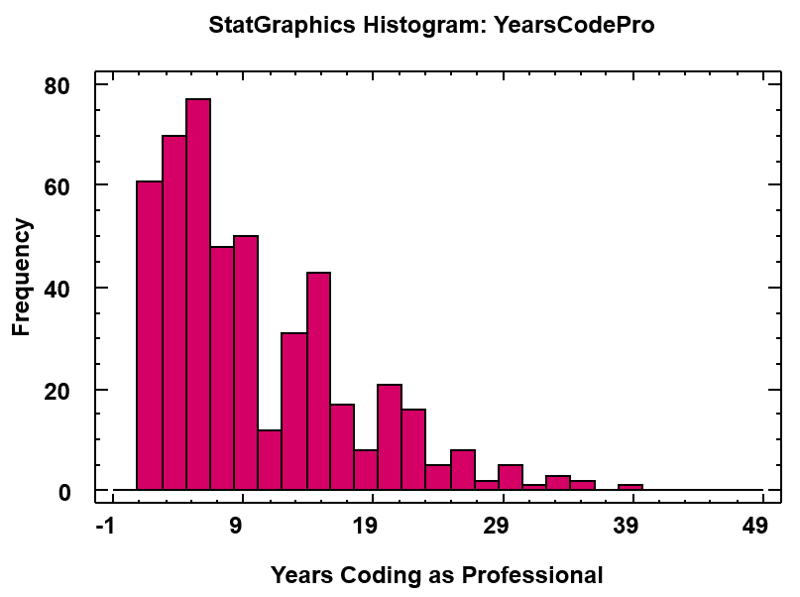

PICTURE

PICTURE 16 clases lim 46

PICTURE class 27 lim 19 69

PICTURE 16 clases, 19 69 lim

PICTURE 27 clases -10000 230000

PICTURE class 24 lim 0 230000